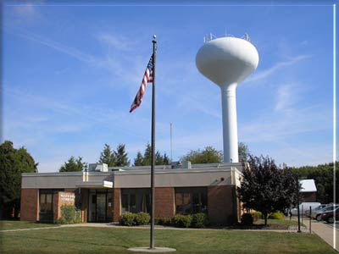 ** ALL FIELDS ARE REQUIRED TO BE FILLED OUT, OR APPLICATION WILL NOT BE ACCEPTED**
Upper Southampton Municipal Authority
945 Street Road, P.O. Box 481
Southampton, PA 18966
(215) 364-1390 Fax (215) 364-9410

CERTIFICATION REQUEST

Property address ________________________________________________________

Seller(s) Name(s) _______________________________________________________

Seller Phone ____________________ Seller email_____________________________

Forwarding address______________________________________________________

Title Co./Conveyancer ________________________ Phone # ____________________

Realtor Name ___________________________ Phone #_________________________

Date of Settlement__________________ Time of Settlement ________ am pm

Certification sent to__________________________ Fax:__________________________

Buyer Name(s) __________________________________________________________

Buyer Phone____________________ Buyer email ______________________________

IF SETTLEMENT DATE CHANGES, YOU MUST NOTIFY US IMMEDIATLEY!
$100 CERT FEE WILL BE REQUIRED IF NOTIFIED AFTER ORIGINAL SETTLEMENT DATE

Office Use Only
Account #____________ Final Read_________Sump Inspect____Lateral Inspect______

Notes:___________________________________________________________________

_________________________________________________________________________

